GRAHAM AND DODDSVILLE – HOME PAGE

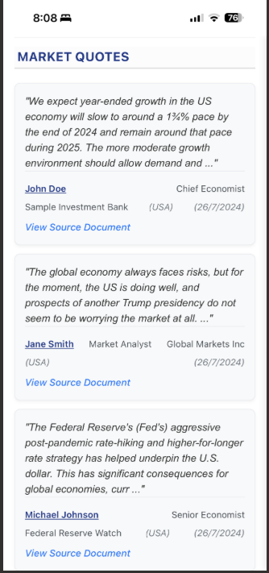
When I click on the name or quote, I want that particular quote to appear at the top of the secondary page (instead of always displaying the most recent quote). Does that make sense?

Change all “View Source Document” to “View source document”.


Delete

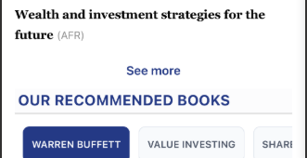
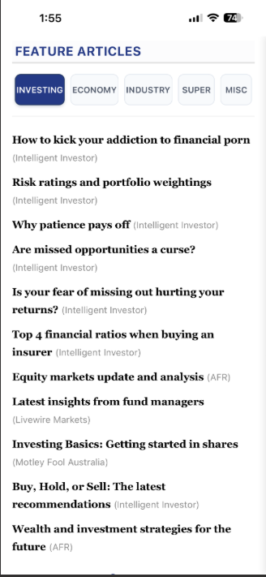
The font size and line spacing of “FEATURE ARTICLES” should be exactly the same as for “LATEST NEWS” and “AROUND THE WORLD”. At the moment, it looks like the font is slightly bigger and the line spacing is slightly wider.
I’ve decided that we should delete all the “See more” functions in “FEATURE ARTICLES”. We can just limit the display to 6 articles per tab at any given time

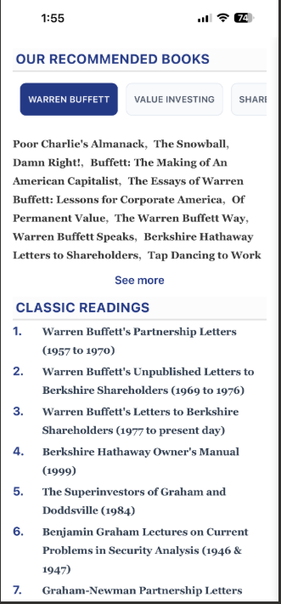
Display 10 lines of books under each tab of “OUR RECOMMENDED BOOKS” (see next two pages for the lists of the books to be displayed in the Home Page).

OUR RECOMMENDED BOOKS:
OUR RECOMMENDED BOOKS

For the “Warren Buffett” tab, can you please display the following books in the Home Page (in this order). You should have 10 lines. Do not put them in italics on the website:

The Essays of Warren Buffett, The Snowball, The Warren Buffett Way, Warren Buffett Speaks, Tap Dancing to Work, Buffett: The Making of an American Capitalist, The Warren Buffett Portfolio, Warren Buffett: An Illustrated Biography, The Deals of Warren Buffett, Of Permanent Value, The Essential Buffett, The Real Warren Buffett, Berkshire Hathaway Letters to Shareholders, Damn Right!, Poor Charlie’s Almanack

For the “Value Investing” tab, can you please display the following books in the Home Page (in this order).

The Intelligent Investor, Security Analysis (1940), Security Analysis (2008), Benjamin Graham On Value Investing, Value Investing: From Graham to Buffett and Beyond, The Rediscovered Benjamin Graham, The Little Book of Value Investing, The Little Book That Beats the Market, You Can Be A Stock Market Genius, Modern Value Investing, Dhandho Investor, Margin of Safety, Value Investing: Tools and Techniques, Deep Value, F Wall St

For the “Share Investing” tab, can you please display the following books in the Home Page (in this order). You should have 10 lines:

How to Make Money in Stocks, One Up on Wall Street, A Beginner’s Guide to the Stock Market, Common Sense on Mutual Funds, The Little Book of Common Sense Investing, Stocks for the Long Run, The Five Rules for Successful Stock Investing, The Little Book That Builds Wealth, Best Loser Wins, Stock Market Investing, The Bogleheads Guide to Investing, Learn to Earn, The Art of Quality Investing, A Random Walk Down Wall Street

Note: Don’t worry about url linking the books to Amazon at this stage. We will do that later once I have set up a referral account with Amazon.

For the “Wealth Creation” tab, can you please display the following books in the Home Page (in this order):

How to Get Rich, Rich Dad Poor Dad, The Simple Path to Wealth, I Will Teach You to be Rich, The Richest Man in Babylon, The Millionaire Next Door, The Millionaire Mind, The Millionaire Fastlane, The Strategic Millionaire, Millionaire Mission, The Science of Getting Rich, Secrets of the Millionaire Mind, Simple Money Rich Life, $1M Money Models, Money Magnet, Cashflow Quadrant, Get Good With Money, Psychology of Money

For the “Financial Analysis” tab, can you please display the following books in the Home Page (in this order):

Financial Statements, How to Read a Financial Report, Financial Shenanigans, Bemused Investor’s Guide to Company Accounts, Warren Buffett Accounting, Accounting for Beginners, Financial Intelligence, Balance Sheet Basics, Financial Statement Analysis for Value Investors, The Interpretation of Financial Statements, How to Value Company Stocks, Valuation, Damodaran on Valuation, Buffettology

For the “Sales and Marketing” tab, can you please display the following books in the Home Page (in this order):

$100M Offers, $100M Leads, Sell or Be Sold, This Is Marketing, The 1-Page Marketing Plan, 80/20 Sales and Marketing, Gap Selling, The Challenger Sale, The Psychology of Selling, Selling 101, Fanatical Prospecting, Secrets of Closing the Sale, Ninja Selling, Go Pro, Building a Story Brand, The 22 Immutable Laws of Marketing, Exactly What To Say, Sell Like Crazy, How to be Great Salesperson, Way Of the Wolf, New Sales Simplified

For the “Self-Improvement” tab, can you please display the following books in the Home Page (in this order):

Atomic Habits, The Mountain Is You, Good Vibes Good Life, The Power of Discipline, The Let Them Theory, Stop Overthinking, Breaking the Habits of Being Yourself, The 7 Habits of Highly Effective People, The 15 Invaluable Laws of Growth, Success, No Excuses!, The Master Key System, How to Talk to Anyone, When Things Fall Apart, Self Doubt Workbook for Women, Love Yourself Like Your Life Depends On It, Awaken The Giant Within

For the “Business & Management” tab, can you please display the following books in the Home Page (in this order):

Never Split the Difference, The Lean Startup, Leaders Eat Last, The Coaching Habit, The E-Myth Revisited, Traction, Surrounded By Idiots, Profit First, Personal MBA, The Infinite Game, Your Next Five Moves, Legacy, The Making of a Manager, The New One Minute Manager, The Diary of a CEO, Million Dollar Weekend, Build to Sell, Buy Back Your Time, Business Made Simple, 12 Months to $1 Million, What’s Your Dream, Business Book

For the “Miscellaneous” tab, can you please display the following books in the Home Page (in this order):

The Big Short, Deep Simplicity, Moneyball, Flash Boys, Liar’s Poker, The Fifth Risk, Bull!, Going Infinite, Tools and Weapons, The Third Chimpanzee, Selfish Gene, Three Scientists and their Gods, Investing Between the Lines, The Autobiography of Benjamin Franklin, Extraordinary Popular Delusions and the Madness of Crowds, A Short History of Nearly Everything, The Black Swan, Fooled by Randomness, Smartest Guys in the Room

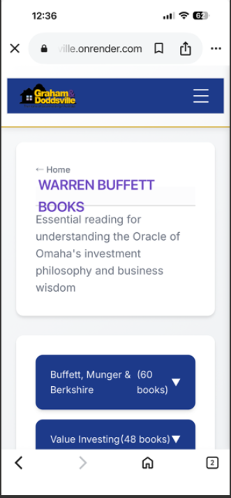
Change “WARREN BUFFETT BOOKS” to “OUR RECOMMENDED BOOKS”. Please make sure the words do not overlap with the horizontal line or with the word “Essential”.



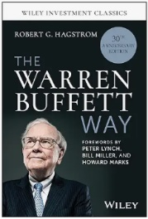
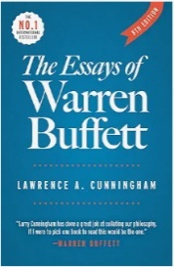
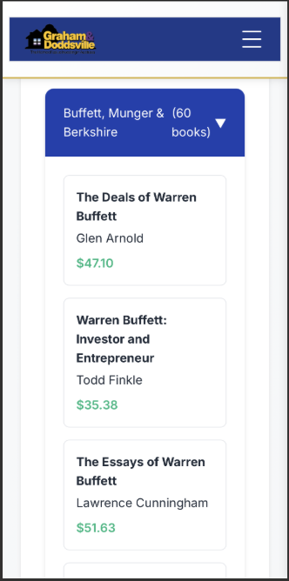
This should just say “Warren Buffett”
Also, is it possible to have an option to sort each book list by:
Rating
Title
Author
Date
Price

But the default order of the books should be as per pages 5 and 6, above
The Warren Buffett Way

Book summary
BUY NOW
$9.14
The Essays of Warren Buffett

Book summary
BUY NOW
$51.63
The full book list should be presented in the secondary pages as follows:
Delete the author’s name
Insert book cover image
Insert “Book summary”
Insert “BUY NOW”
And then the price is at the bottom.

(see example to the left)

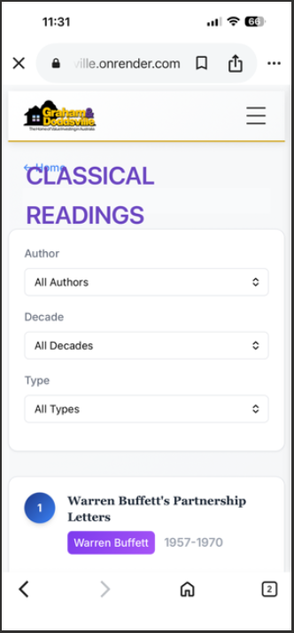
The word “Classical” should be “Classic”.

Also it is overlapping with the word “Home”. Please reformat to remove the overlap.

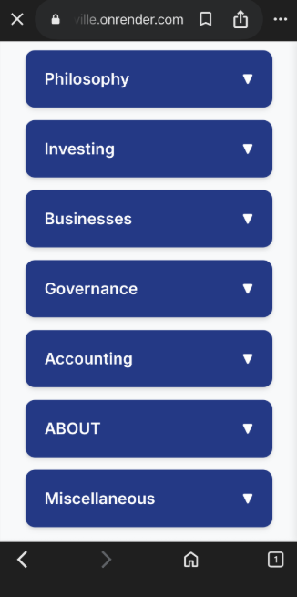
This secondary page will no longer be necessary (see further below).

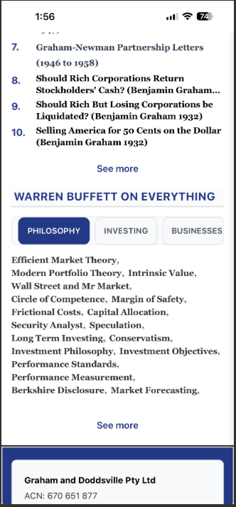
Delete the “See more” function for all of the tabs under “WARREN BUFFETT ON EVERYTHING”.
Documents 8 to 10 should have the same line spacing as documents 1 to 7.

For the “Governance” tab, can you please display the following terms in the Home Page (in this order). Make sure there are 11 lines. Do not include the italics:

Annual meetings, Audit Committee, Auditors,
Berkshire Compensation, CEO Compensation, CEO Mistakes, Corporate Charity, Corporate Culture, Corporate Expense, Corporate Governance, Corporate Responsibility, Corporate Strategy, Director Remuneration, Directors' Role, Directors' Weaknesses , Dividend Policy, Executive Compensation, Hiring and Firing, Independent Directors, Organisational Structure, Remuneration Committee, Shareholders, Succession

For the “Accounting” tab, can you please display the following terms in the Home Page (in this order). Make sure there are 11 lines. Do not include the italics:

Accounting Creativity, Accounting Ratios, Accounting Goodwill, Amortization, Book Value, Capital Base, Capital Gain, Cash Flow, Compounding, Debt, Depreciation, Earnings, Earnings Per Share, EBITDA, Economic, Goodwill, Fraud, Full and Fair Reporting, Intangibles, GAAP, Leverage, Liquidation, Look through earnings, Owner Earnings, PE Ratio, Pro Forma Reporting, Realised Gains and Losses, Retention of Earning, Return on Capital, Return on Equity, Valuation

For the “Economics” tab, can you please display the following terms in the Home Page (in this order). Do not include the italics:

Budget Deficit, Currency, Globalisation, Global Economy, Gross Domestic Product, Inflation, Interest Rates, International Trade, Macroeconomics, Recession, Trade Imbalance, US Economy

For the “Miscellaneous” tab, can you please display the following terms in the Home Page (in this order). Do not include the italics:

Benjamin Graham, Character, Charlie Munger, David Dodd, Happiness, Love, Partnership, Philanthropy, Public Pension, Success, Taxation, Unconventional Commitments
For the “Philosophy” tab, can you please display the following terms in the Home Page (in this order). Make sure there are 11 lines. Do not include the italics:

Investment Philosophy, Investment Objectives,
Modern Portfolio Theory, Value Investing, Successful Investing, Intrinsic Value, Wall Street and Mr Market, Circle of Competence, Long Term Investing, Conservatism, Security Analyst, Margin of Safety, Market Forecasting, Market Timing, Speculation, Performance Standards, Performance Measurement, Mistakes, Frictional Costs, Capital Allocation, Market Bubble, Market Downturn, Exit Strategy, Berkshire Disclosure, Value Investors

For the “Investing” tab, can you please display the following terms in the Home Page (in this order). Make sure there are 11 lines. Do not include the italics:

Stock Market, Portfolio Allocation, Buying Criteria, Selling Criteria, Investment Strategy,
Investment Advice, Investment Risk, Volatility
Rumours, Technical Analysis, Share Buybacks,
Share Issues, Stock Splits, Stock Options, Book Recommendations, Indexing, Arbitrage, Cigar Butt Investing, Mergers and Acquisitions, Workouts, Derivatives, The Dow, Fees, Bonds, Gold, Diversification, Initial Public Offering, Convertible Preferred Stock, Junk Bonds, Private Equity, Real Estate

For the “Businesses” tab, can you please display the following terms in the Home Page (in this order). Make sure there are 11 lines. Do not include the italics:

Good Businesses, Economic Moat, Good Managers, Poor Businesses, Poor Managers, Airlines, Auto Insurance, Banks, Berkshire Hathaway, Controlled Businesses, Derivatives Business, Float, Franchises, Insurance, Investment Banks, Investment Companies, Investment Managers, Manufactured Housing, Paper, Property Casualty Insurance, Reinsurance, Retail, Retroactive Insurance, Shoes, Super Cat Insurance, Technology, Television, Textile, Transport, Utilities

